2026 World Tai Chi & Qigong Day
Long Sleeve Tee-Shirt Order Sheet
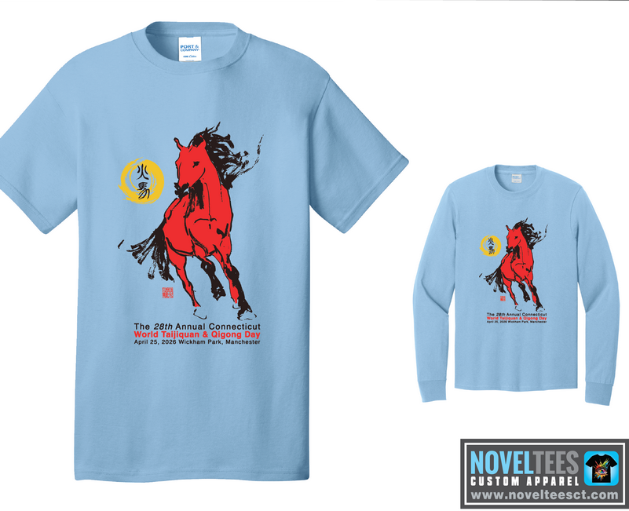 | 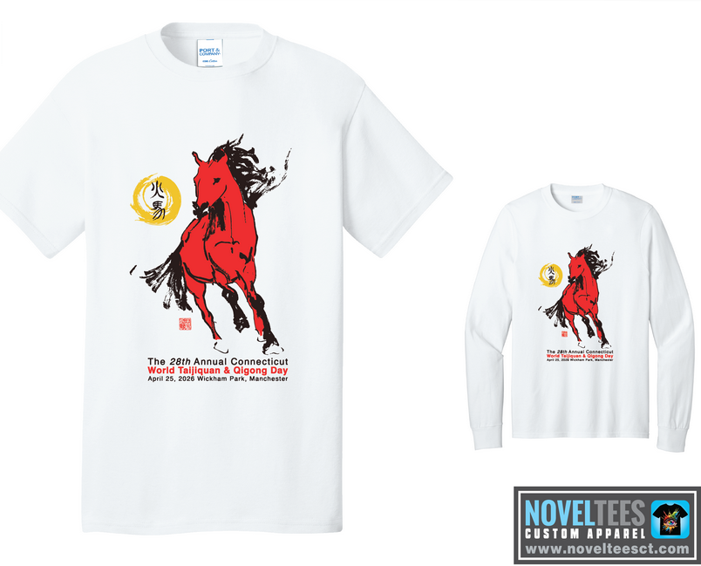 | 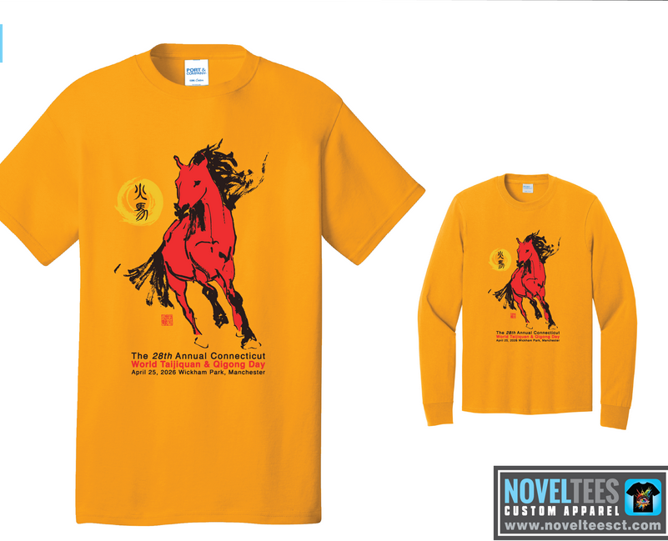
Light Blue (LB) | White (WT) | Gold (GD)
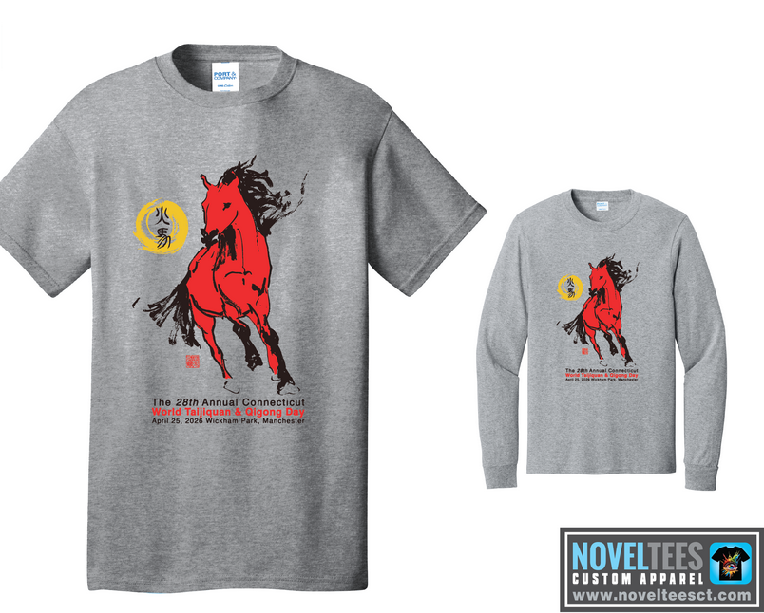 | 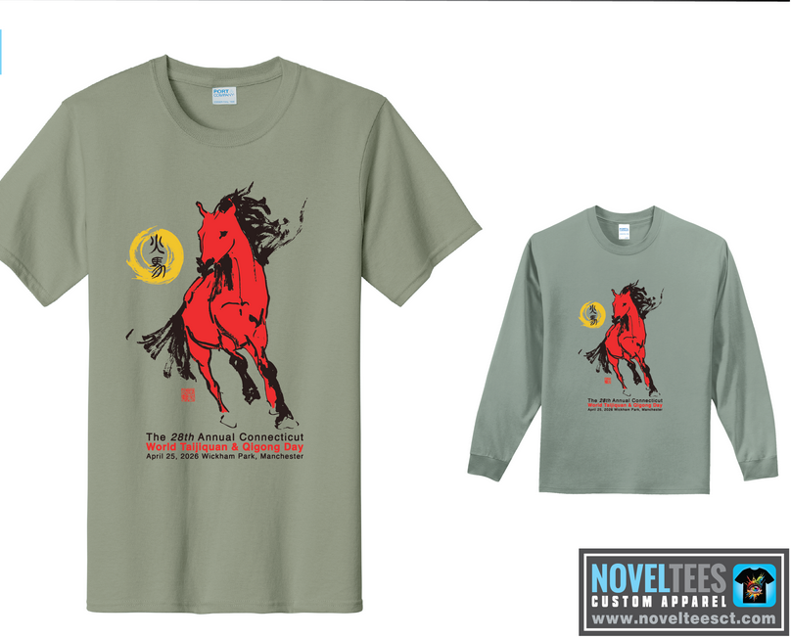 | 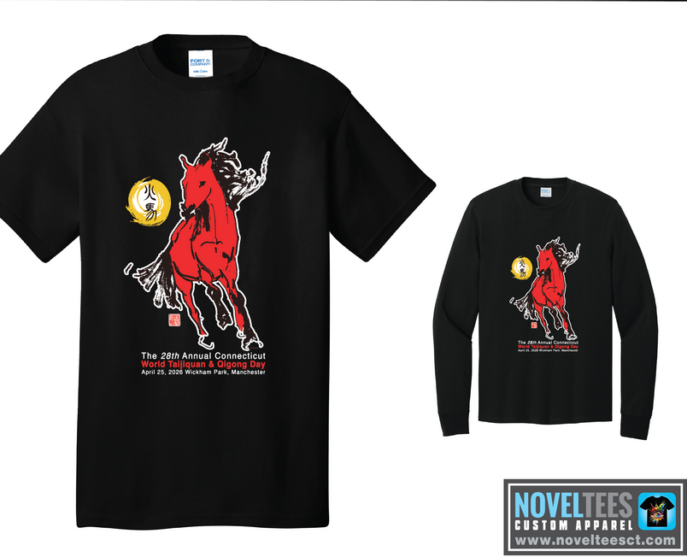
Heather Grey (HG) | Stonewash Green (SG) | Black (BK)

Name | Email / Phone | Color | Long Sleeve  Size S / M  $25  L / XL | Size 2XL  add $3 | Size 3XL  add $3 | Total Amt | Paid
Ultra Cotton T-Shirts are 100% Cotton. Colors from Manufacturer’s website catalogue may not reproduce exactly as shown here.
Shirts are available in short. Adult sizes: Small, Medium, Large, XLarge, XXL, and XXXL. Add $3 for each XXL or XXXL shirt.

